Behavioural Design Patterns :

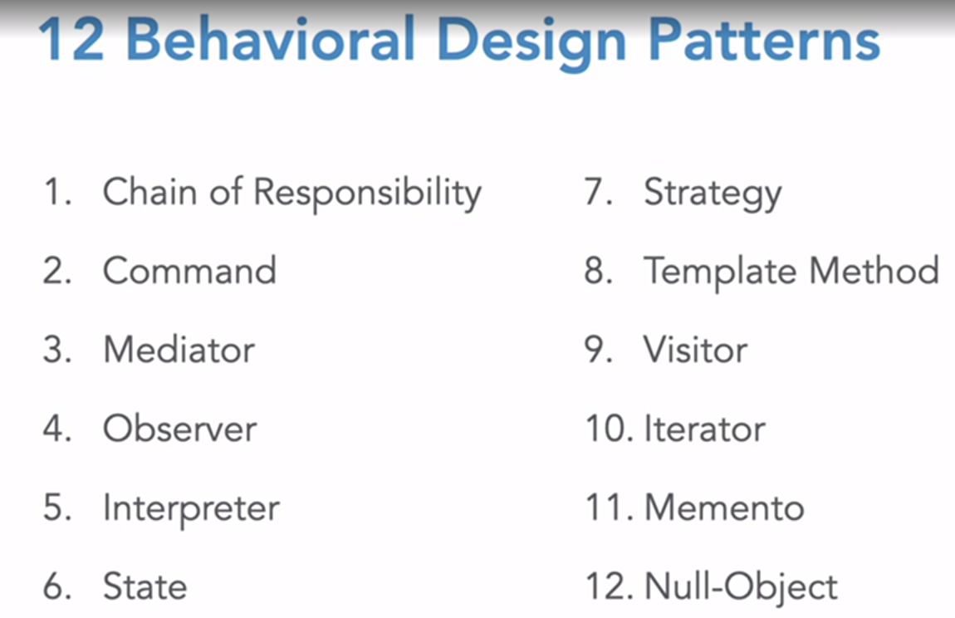

Chain of responsibility: Let’s say you have an input validator which has to go through a lot of checks before being accepted, one way to accomplish this is by using a series of if else conditions, but this is clumsy code, and when the condition changes, you will have to copy paste your logic. In this case we use chain of responsibility pattern.  
Here, the current state calls the next state, if the first state is cleared / passed.  
Ex : password validator, code available in qt file.

#include <QCoreApplication>

#include <iostream>

#include <vector>

#include <regex>

class StringValidator {

public:

virtual StringValidator *setNext(StringValidator *nextValidator) = 0;

virtual ~StringValidator() {};

virtual std::string validate(std::string) = 0;

};

class BaseValidator : public StringValidator {

protected:

StringValidator *next = nullptr;

public:

~BaseValidator() { delete next; };

StringValidator *setNext(StringValidator *nextValidator) override {

next = nextValidator;

return nextValidator;

}

virtual std::string validate(std::string testString) override {

if (this->next) {

return this->next->validate(testString);

}

return "Success!";

}

};

class NotEmptyValidator: public BaseValidator {

public:

std::string validate(std::string testString) override {

std::cout << "Checking if empty...\n";

if (testString.empty()) {

return "Please enter a value";

}

return BaseValidator::validate(testString);

}

};

class LengthValidator: public BaseValidator {

int minLength;

public:

LengthValidator(int minLength) : minLength(minLength) {};

std::string validate(std::string testString) override {

std::cout << "Checking if length equals" << minLength << "...\n";

if (testString.length() < minLength) {

return "Please enter a value longer than " + std::to_string(minLength);

}

return BaseValidator::validate(testString);

}

};

class RegexValidator: public BaseValidator {

std::string patternName;

std::string regexString;

public:

RegexValidator(std::string patternName, std::string regexString)

: patternName(patternName), regexString(regexString) {};

std::string validate(std::string testString) override {

std::cout << "Checking if string is a valid " << patternName << "...\n";

if (!std::regex_match(testString, std::regex(regexString))) {

return "The value entered is not a valid " + patternName;

}

return BaseValidator::validate(testString);

}

};

bool in_vector(const std::string &value, const std::vector<std::string> &v) {

return std::find(v.begin(), v.end(), value) != v.end();

}

class HistoryValidator: public BaseValidator {

std::vector<std::string> historyItems;

public:

HistoryValidator(std::vector<std::string> historyItems) : historyItems(historyItems) {};

std::string validate(std::string testString) override {

std::cout << "Checking if string is in history...\n";

if (in_vector(testString, historyItems)) {

return "Please enter a value that you haven't entered before";

}

return BaseValidator::validate(testString);

}

};

int main(int argc, char *argv[]) {

QCoreApplication a(argc, argv);

std::vector<std::string> oldPasswords = { "abc123", "12345678", "hello" };

BaseValidator *emailValidator = new BaseValidator;

emailValidator

->setNext(new NotEmptyValidator)

->setNext(new RegexValidator("email address", "^\\w+([-+.']\\w+)*@\\w+([-.]\\w+)*\\.\\w+([-.]\\w+)*$"));

std::cout << "Checking Emails ---------------\n";

std::cout << "Input: \n" << emailValidator->validate("") << "\n\n";

std::cout << "Input: shaun\n" << emailValidator->validate("shaun") << "\n\n";

std::cout << "Input: shaun@test.com\n" << emailValidator->validate("shaun@test.com") << "\n\n";

delete emailValidator;

BaseValidator *pwdValidator = new BaseValidator;

pwdValidator->setNext(new NotEmptyValidator)->setNext(new LengthValidator(8))

->setNext(new HistoryValidator(oldPasswords));

std::cout << "Checking passwords ---------------\n";

std::cout<< "input :"<<pwdValidator->validate("1234568")<<"\n";

return a.exec();

}

CHAIN OF RESPONSIBILITY :   
Sequence of handlers processing an event after another.

Example : You can click a graphical element on a form :

* Button handles it, stops further processing
* Underlying group box
* Underlying window.

A chain of components who all get a chance to process a command or query, optionally having default processing implementation and an ability to terminate the processing chain.

Implementation :

Can be thought of as a singly linked list of pointers.   
The first pointer example he took was of a video game, in which If a character is in default state, he has certain powers and defenses, but if he has a booster mode activated, his powers and defenses increases.  
So create a class called creatureModifier, which can modify the characteristics of the creature in several ways. And this creatureModifier class is a singly linked list which has a member variable called next; and we have a reference to a creature defined.  
we have two important functions here, one is to add the next member of the modifier.  
other function is a virtual handle function which is overridden in consecutive handler  
In this function, we have called, if(next) , next->handle(); // appropriate handle function should be called.  
  
In the classes derived from this creatureModifier class, we have handle function called, which modifies the creature and also calls the next handler with this line CreatureModifier::handle();  
If you want to nullify the effects of all the booster modifiers, you add a noBonuses class and in that handle() will have CreatureModifier::handle() line deleted which will not let any further modifiers propagate to the creature.

Since this implementation of chain of responsibility relies on linked list implementation, people ask why we don’t simply use a std::list for all these questions. However, chain of responsibility is not applied like this any more.

In the next example, he has implemented this pattern through event broker which is a combination of observer(signals) design patter + command query separation + chain of responsibility.  
Also covered mediator design pattern here.

COMMAND DESIGN PATTERN :  
to remove the tight coupling of classes, this pattern is used.  
He took the example of a canvas in which various shapers were added, and there was a clear canvas button whose job was to clear everything. Initially, before applying the pattern, he had separate classes for every type of button like squareButton, triangleButton, etc. and these classes were tightly coupled with Canvas class.  
To remove this dependency, he introduced a command class which had an execute method, refer code below :

class Command {

public:

virtual ~Command() {};

virtual void execute() = 0;

};

class Canvas {

std::vector<std::string> shapes;

public:

void addShape(const std::string & newShape) {

shapes.push_back(newShape);

};

void clearAll() {

shapes.clear();

};

std::vector<std::string> getShapes() { return shapes; };

};

class AddShapeCommand: public Command {

std::string shapeName;

Canvas *canvas;

public:

AddShapeCommand(const std::string & shapeName, Canvas* canvas) : shapeName(shapeName), canvas(canvas) {};

void execute() {

canvas->addShape(shapeName);

}

};

class ClearCommand: public Command {

Canvas *canvas;

public:

ClearCommand(Canvas *canvas) : canvas(canvas) {};

void execute() {

canvas->clearAll();

}

};

class Button {

Command *command;

public:

Button(Command *command) : command(command) {}

~Button() { delete command; };

virtual void click() {

command->execute();

};

};

std::string vectorToString(std::vector<std::string> v) {

std::string result = "";

for(int i=0; i < v.size(); i++) {

result.append(v.at(i) + ", ");

}

return result;

}

int main(int argc, char *argv[])

{

QCoreApplication a(argc, argv);

Canvas *canvas = new Canvas;

Button *addTriangleButton = new Button(new AddShapeCommand("triangle", canvas));

Button *addSquareButton = new Button(new AddShapeCommand("square", canvas));

Button *clearButton = new Button(new ClearCommand(canvas));

addTriangleButton->click();

std::cout << "Current canvas state: " << vectorToString(canvas->getShapes()) << "\n";

addSquareButton->click();

addSquareButton->click();

addTriangleButton->click();

std::cout << "Current canvas state: " << vectorToString(canvas->getShapes()) << "\n";

clearButton->click();

std::cout << "Current canvas state: " << vectorToString(canvas->getShapes()) << "\n";

delete canvas;

return a.exec();

}

Command design pattern UDEMY :

He has stated that instead of directly accessing functions of a class, he has taken the help of a command class to execute them in which he has made a virtual function called ,  
struct Command {

Virtual void call()=0;

}

This function is implemented by the derived class, which executes the functions of another class for which this command pattern was introduced. In this way, here again we have eliminated the tight coupling between account class and transaction class.

In next video he had demonstrated composite design pattern in which a set of commands were executed using a single function and those operations were also undone using another function and a flag was used to denote whether a particular operation was successful or not before applying the undo on it.

Motivation :

* Ordinary C++ statements are perishable. ( For eg : if you assign a value to a variable, and then reassign another value, there’s no record of these assignments for that variable.)
* You want an object that represents an operation . For ex :   
  X should change its field Y to value Z or  
  X should do W()

Uses : GUI commands, multilevel undo/redo, macro recording and more.

Command is an object which represents an instruction to perform a particular action. Contains all the information necessary for the action to be taken.

Command query separation : Command is different from a query , as it’s an action. Important in distributed data systems.

However, in GoF book, they have encapsulated queries also in the form of design patterns.

SUMMARY :

* Encapsulate all details of an operation in a separate object.
* Define instructions for applying the command (either in command itself or elsewhere.)
* Optionally define instructions for undoing the command.
* Can create composite commands (a.k.a macros)

MEDIATOR DESIGN PATTERN:

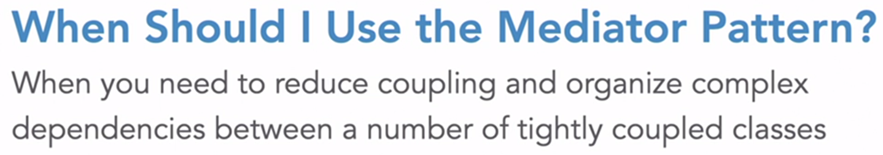

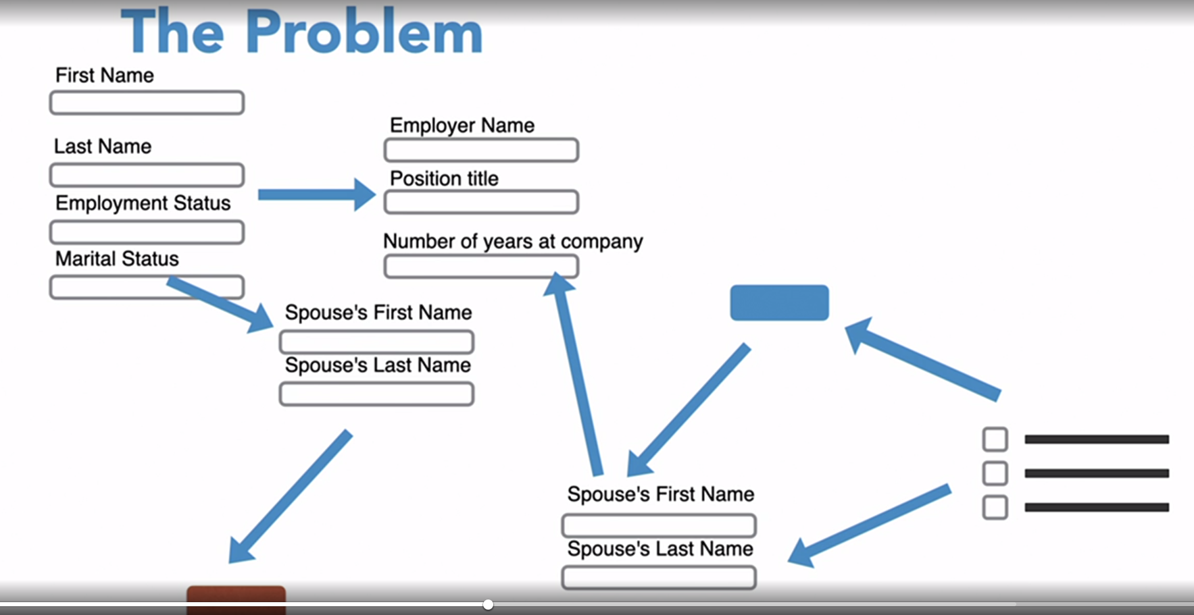

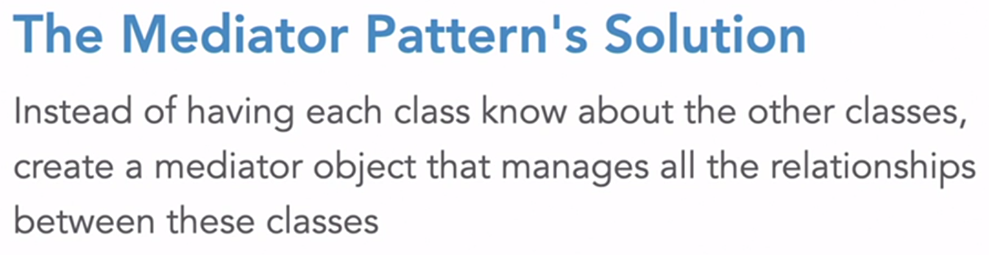

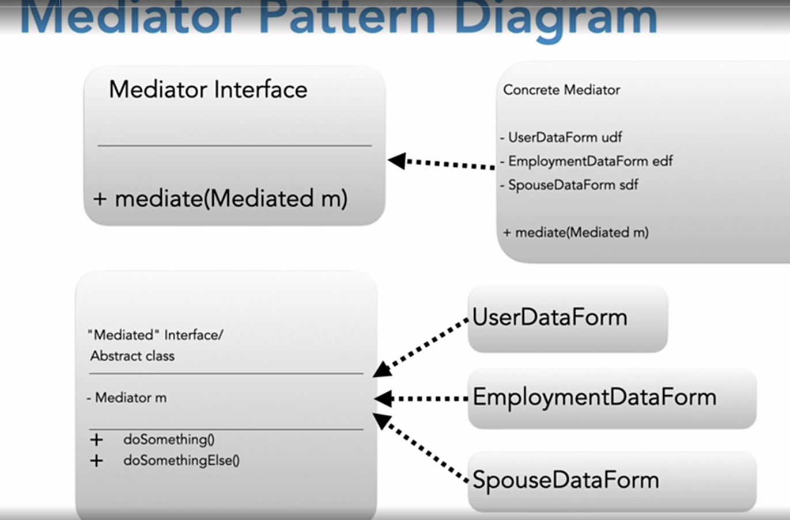

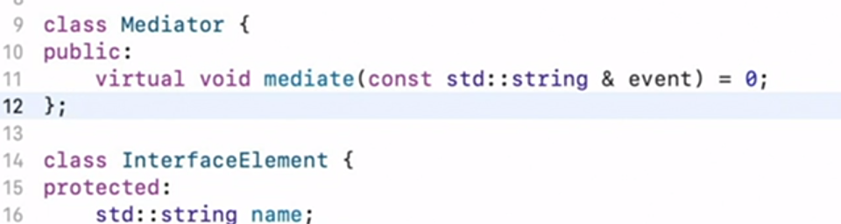

This userInterface inherits mediator class,  
  
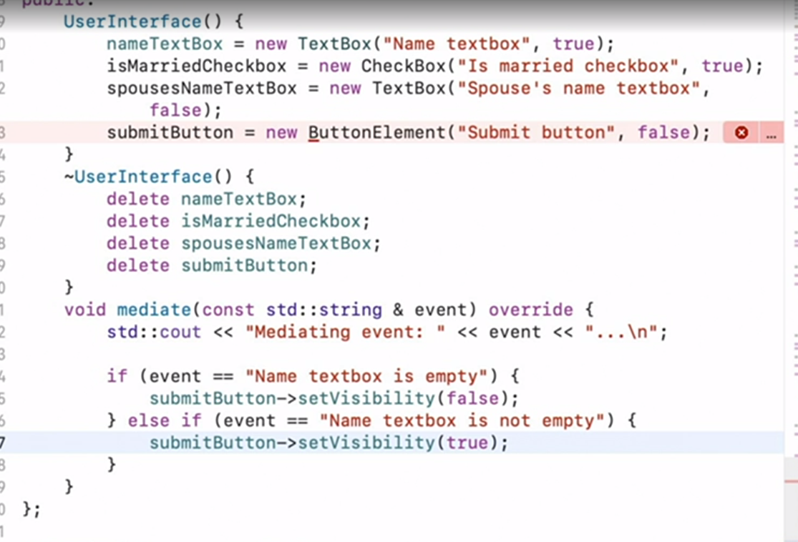

And you need to add mediator to other left classes as well,  
  
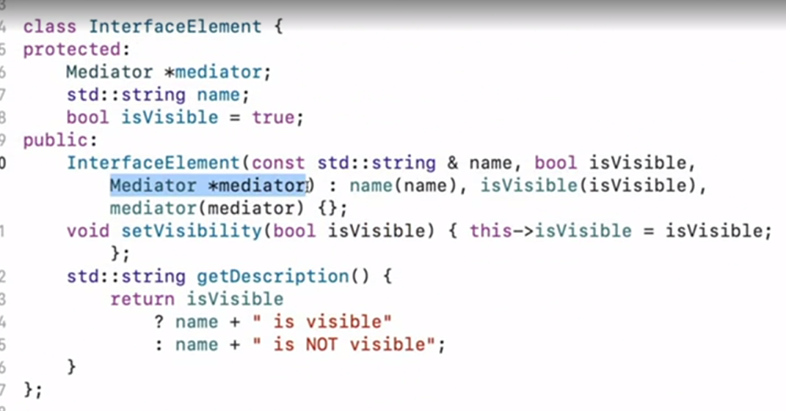

Mediator passed through this keyword in userInterface class :  
  
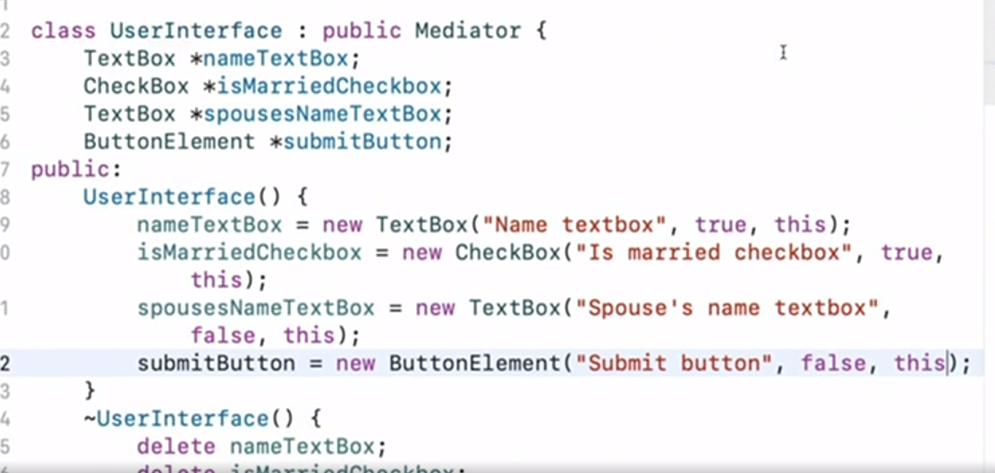

Now the individual classes need to call mediate event,  
  
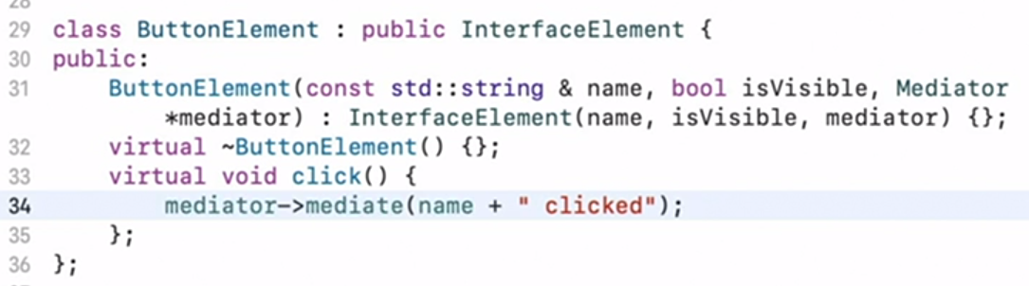

Client side implementation :

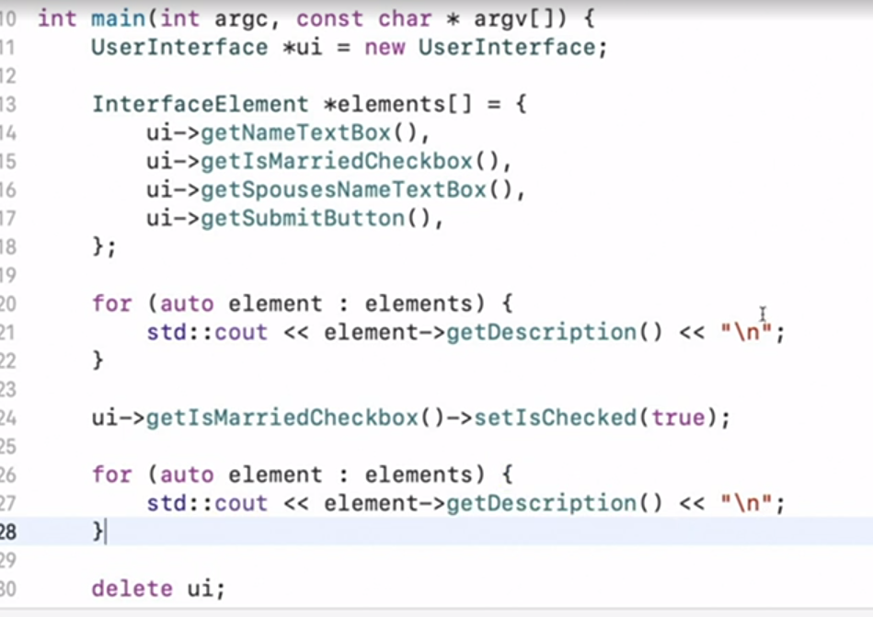

Mediator : udemy :

Facilitates communication between components.

Motivation :

* Components may go in and out of the system at any time. ( eg. : in a chatroom, or in a multiplayer game)
* It makes no sense for them to have direct refernecs to one another as Those references may go dead.

Solution : have them all refer to some central component that facilitates communication.

Mediator : is a component that facilitates communication between other components without them necessarily being aware of each other or having direct (reference) access to each other.

Ex: was taken of a chatroom. Where members joined, the chatroom notifies each of the present members of someone joining , except that member who just joined. And when someone sends message, he sends it via the mediator, (to the chatroom, followed by the message), and if he wants to send private message, again he sends via mediator with function parameter ( receiver, and text message.)

Next, he had an event broker class that that used signal2 class of boost library, in which a coach came out evrytime a goal was scored in the game. Here, the game acted as a mediator amongst coach and players whose reference was included in both the players and the coach.

Mediator is a singleton component.

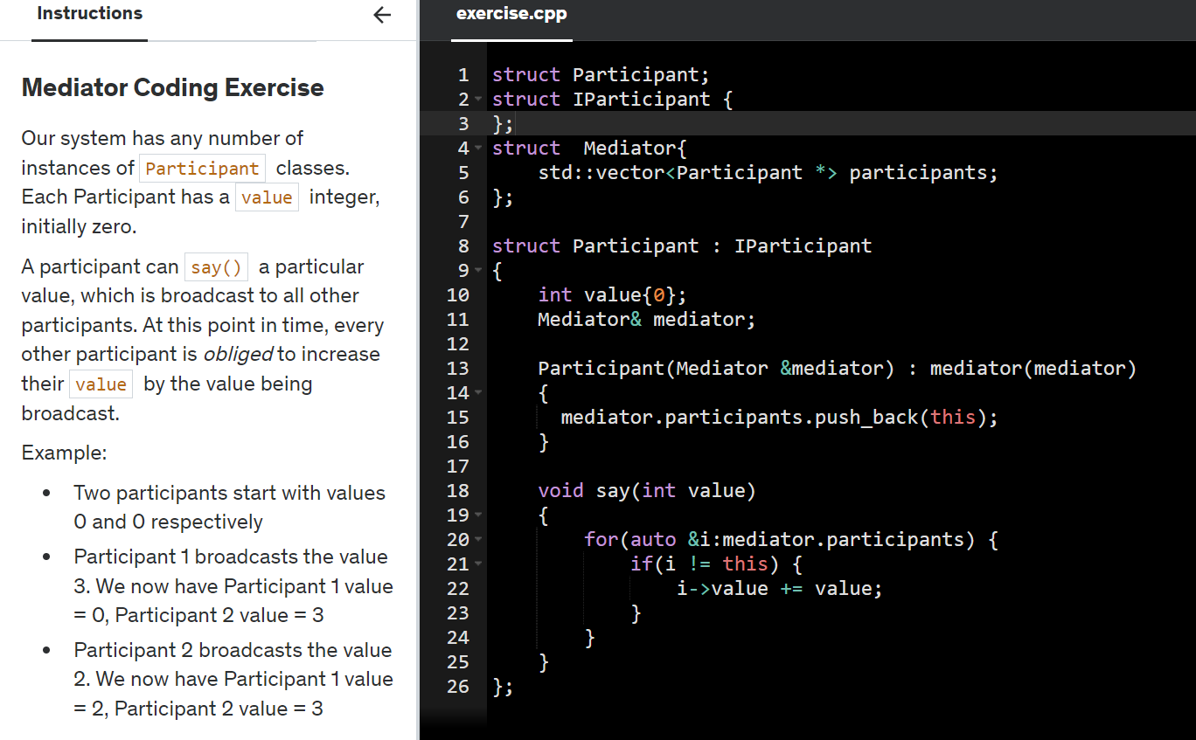

Summary :

- Create the mediator and have each object in the system refer to it.

* Mediator engages in bidirectional communication with its connected components.
* Mediator has functions the component can call.
* Also components themselves have functions that the mediator can call.
* Event processing (ex, Rx) libraries make communication easier to implement.

OBSERVER DESIGN PATTERN :  
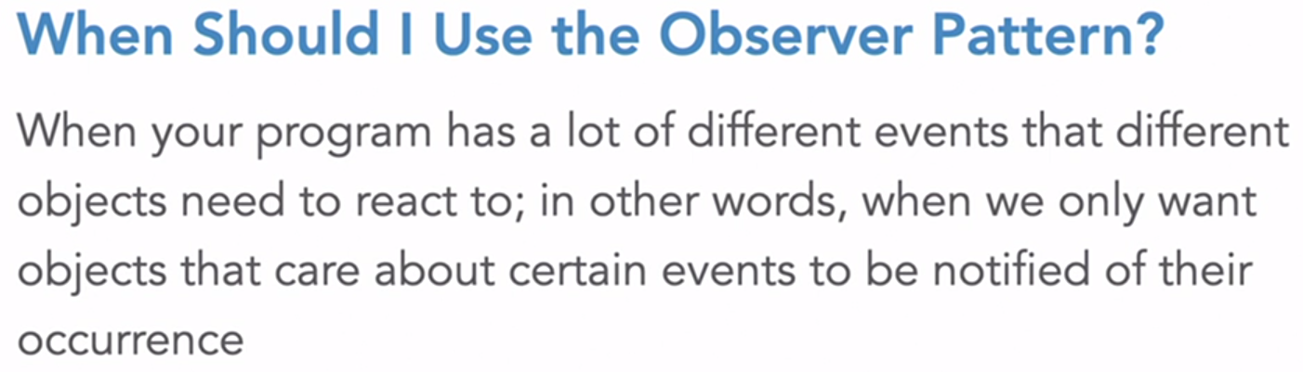

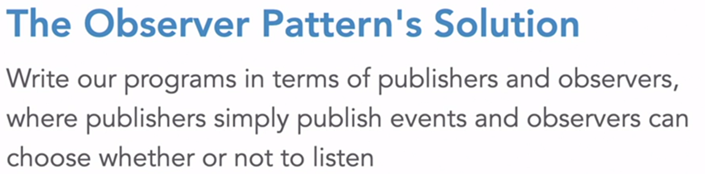

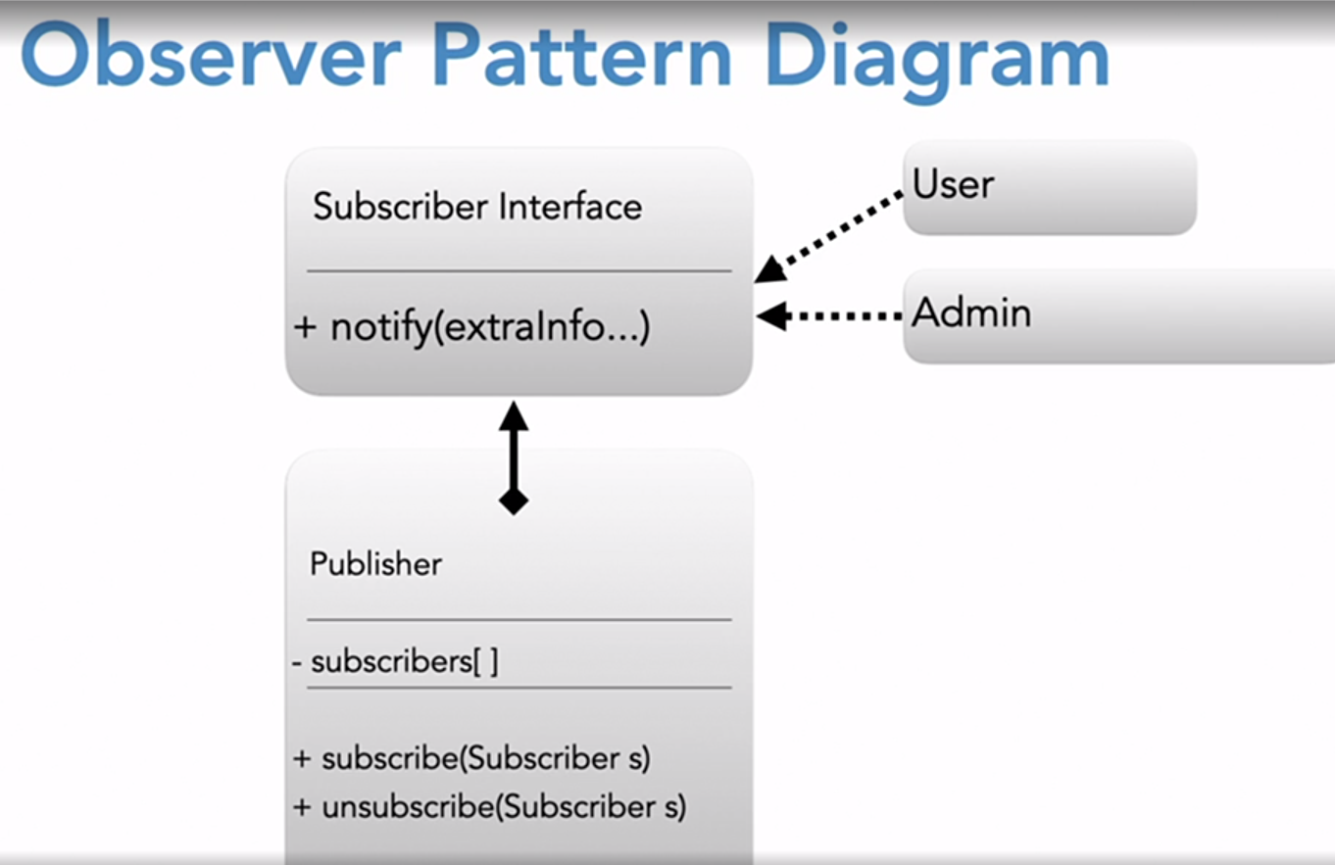

* Someone can subscribe to or unsubscribe from a publisher, that is why these methods are defined here.
* And we are going to notify the Subscriber that is this method is present in the subscriber.

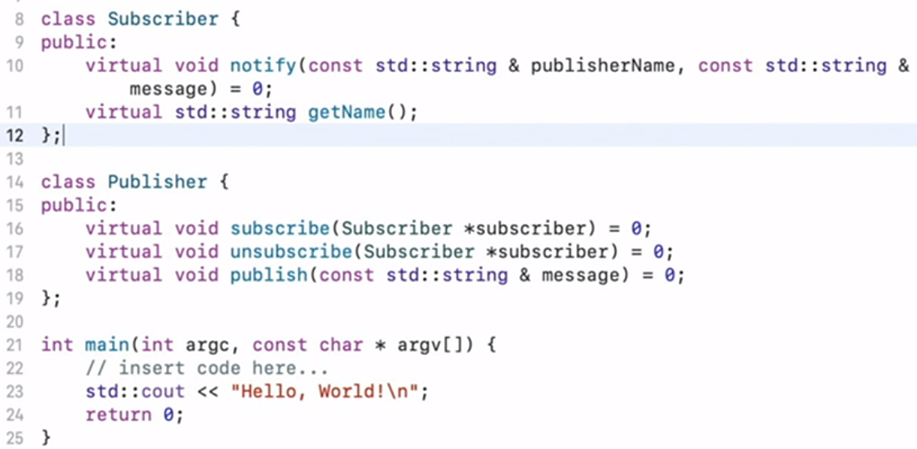

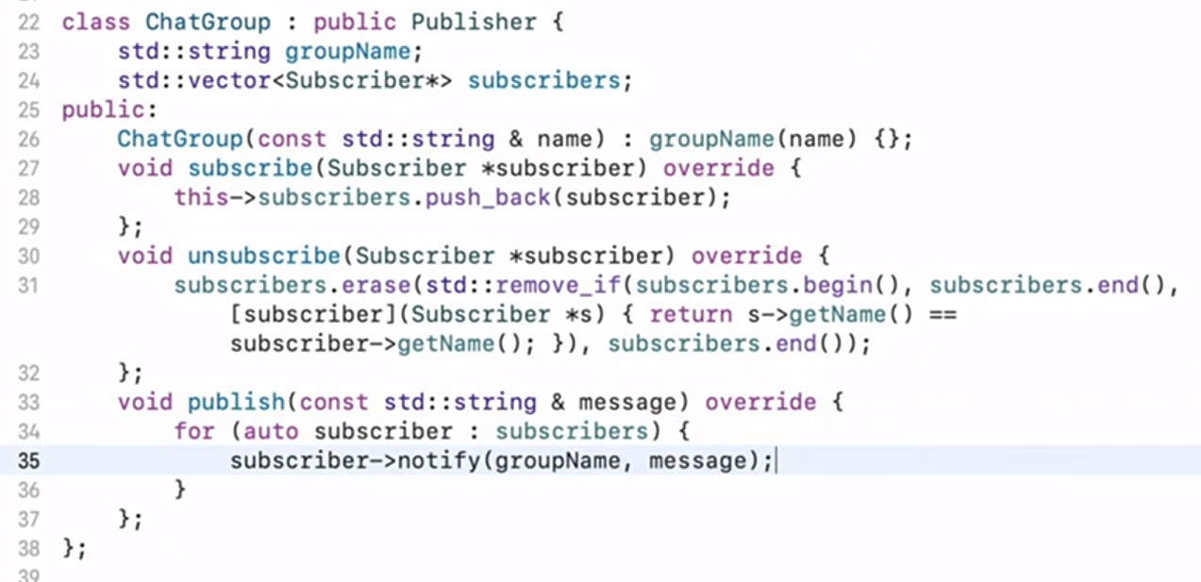

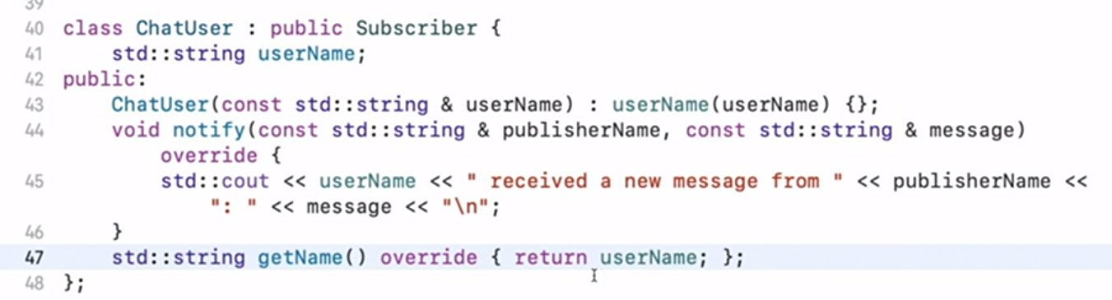  
  
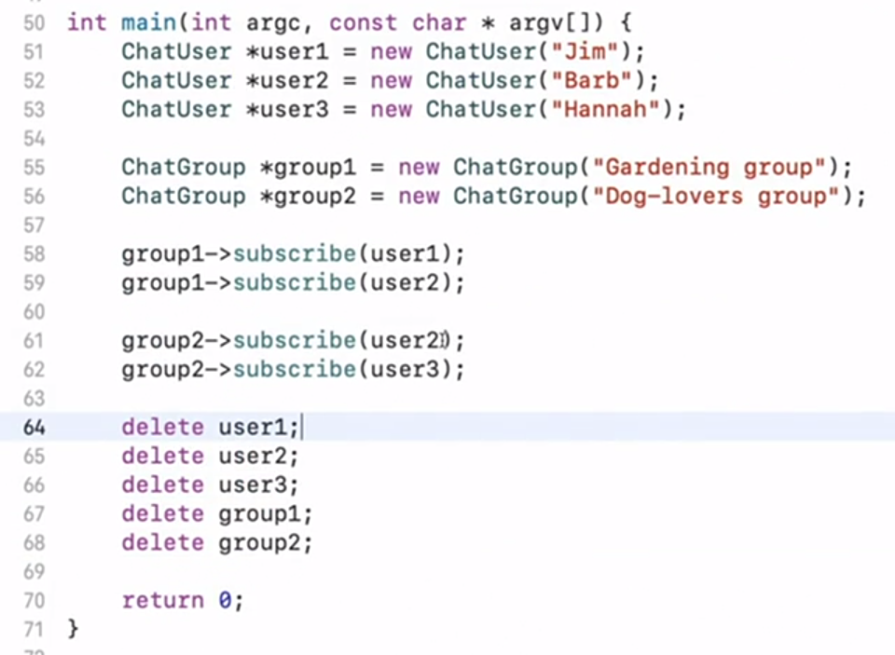

An observer is an object that wishes to be informed about events happening in the system. The entity generating the events is an observable.  
Udemy : he has taken the example of A Person struct whose age is observable. As soon as the person’s age reaches a certain point, the observer is notified.

He used boost’s signal, connect and disconnect methods in one implementation.

There’s the problem of multiple dependencies in observer design pattern. When a certain property which is being changed along with some other property, and we want to send notification only when both of these properties change, it becomes a bit cumbersome to implement.

Thread safety : what would happen if unsubscribe method was called in notify , for example, if we have a traffic administrator who is monitoring people’s ages. Once he is notified, that a person has reached a certain age, he no longer wants to monitor or subscribe to that person.

SO in this case he had initially used std::mutex, and std::scoped_lock to lock every function using this scoped_lock.  
  
Later he suggested using std::recursive_mutex instead of std::mutex to overcome this problem ,but this is more cumbersome.

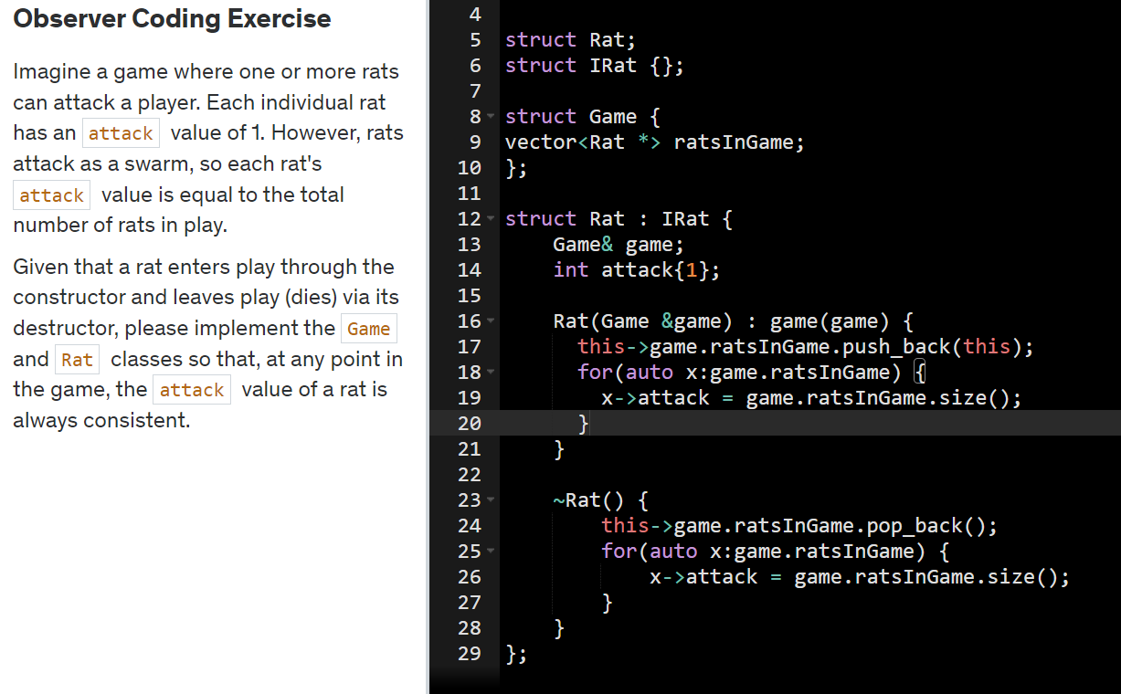

Interpreter design pattern :  
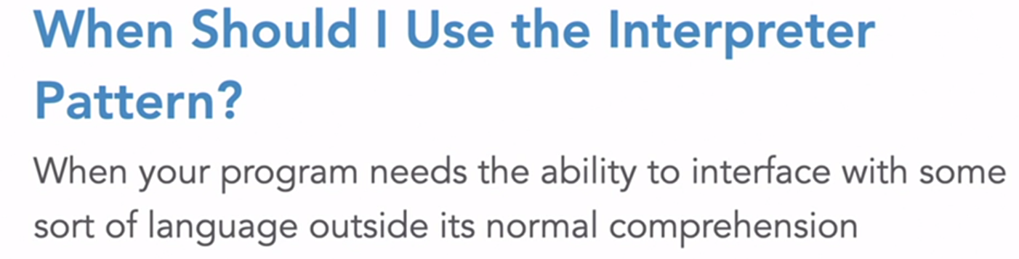

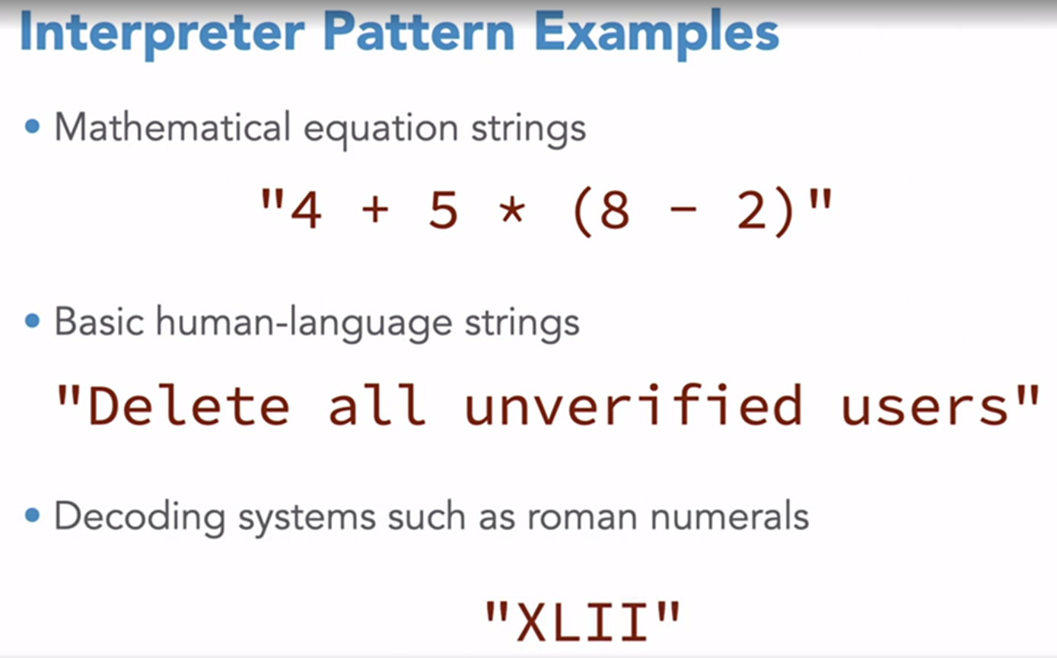

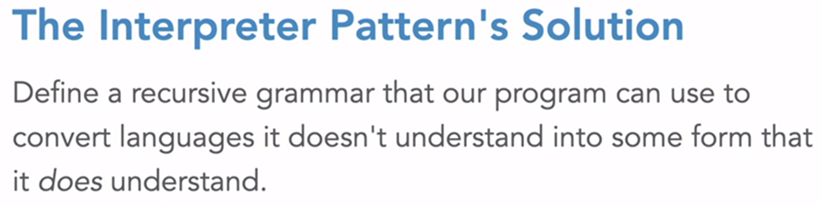

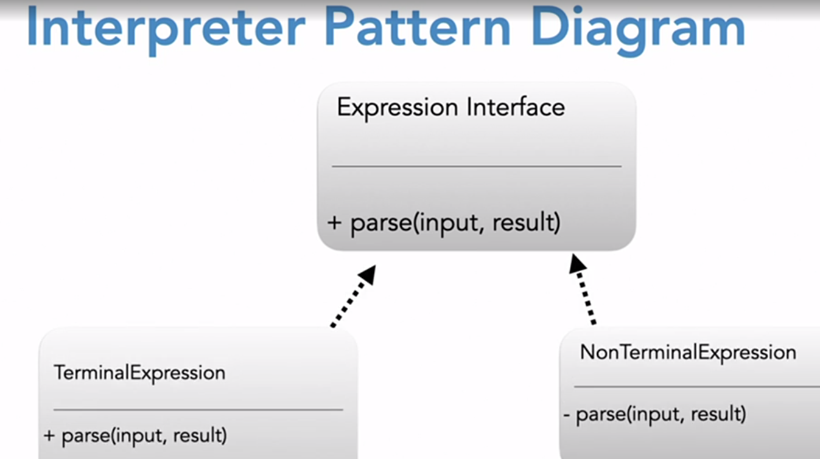

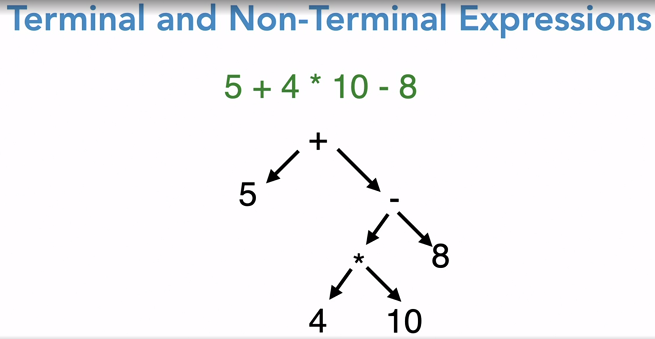

This operation Expression is a non terminal class derived from interface expression :  
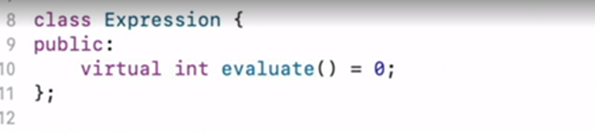

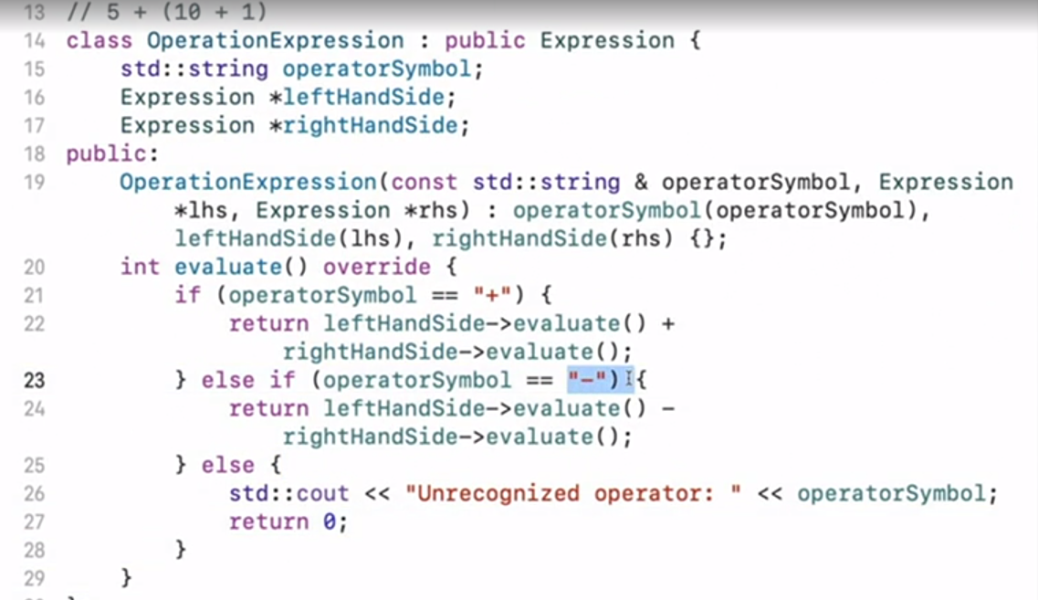

The terminal class :  
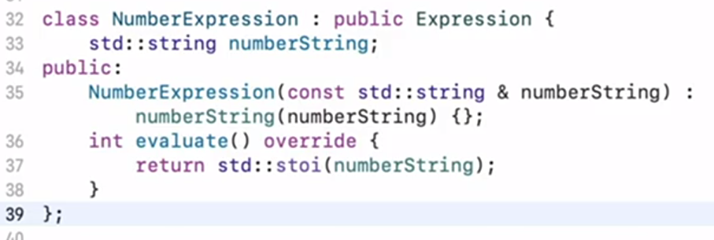

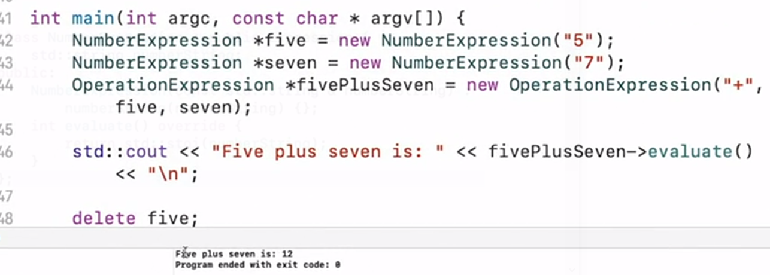

Client code involving a couple of steps:   
  
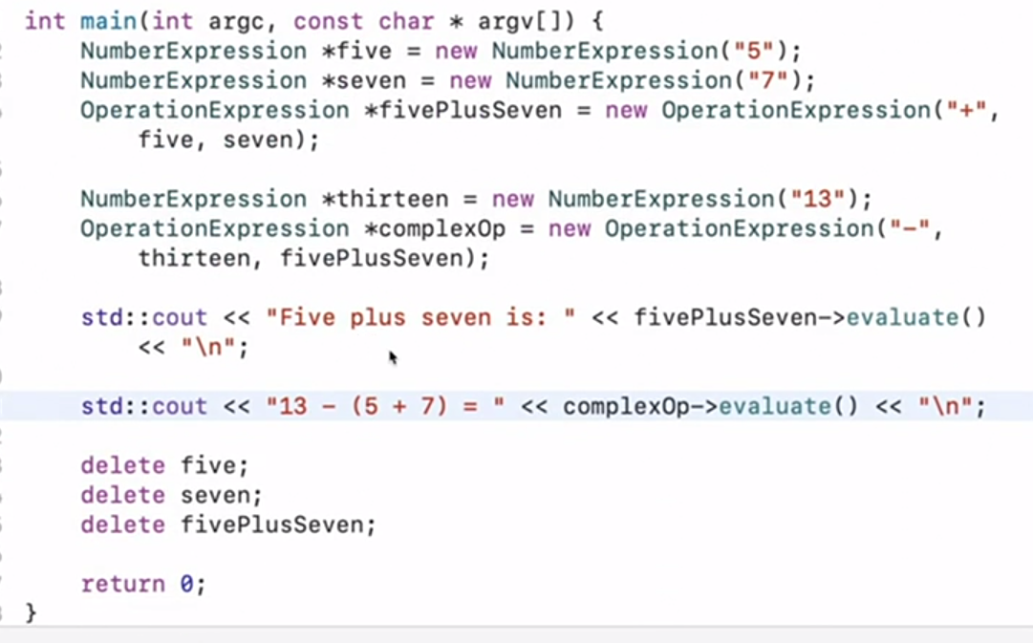

Udemy interpreter :  
-Textual input needs to be processed , eg : turned into OOP structure.

-Some examples :

* Programming language compilers , interpreters and IDEs.
* HTML, XML and similar.
* Numeric expressions (3+4/5)
* Regular expressions
* Turning strings into OOP based structures in a complicated process.

Interpreter : A component that processes structured text data. Does so by turning it into separate lexical tokens (lexing) and then interpreting sequences of said tokens (parsing).

He had again taken example of expression parsing.. very complicated way of doing.  
first he lexed the incoming string into multiple tokens, then he parsed / evaluated that expression.

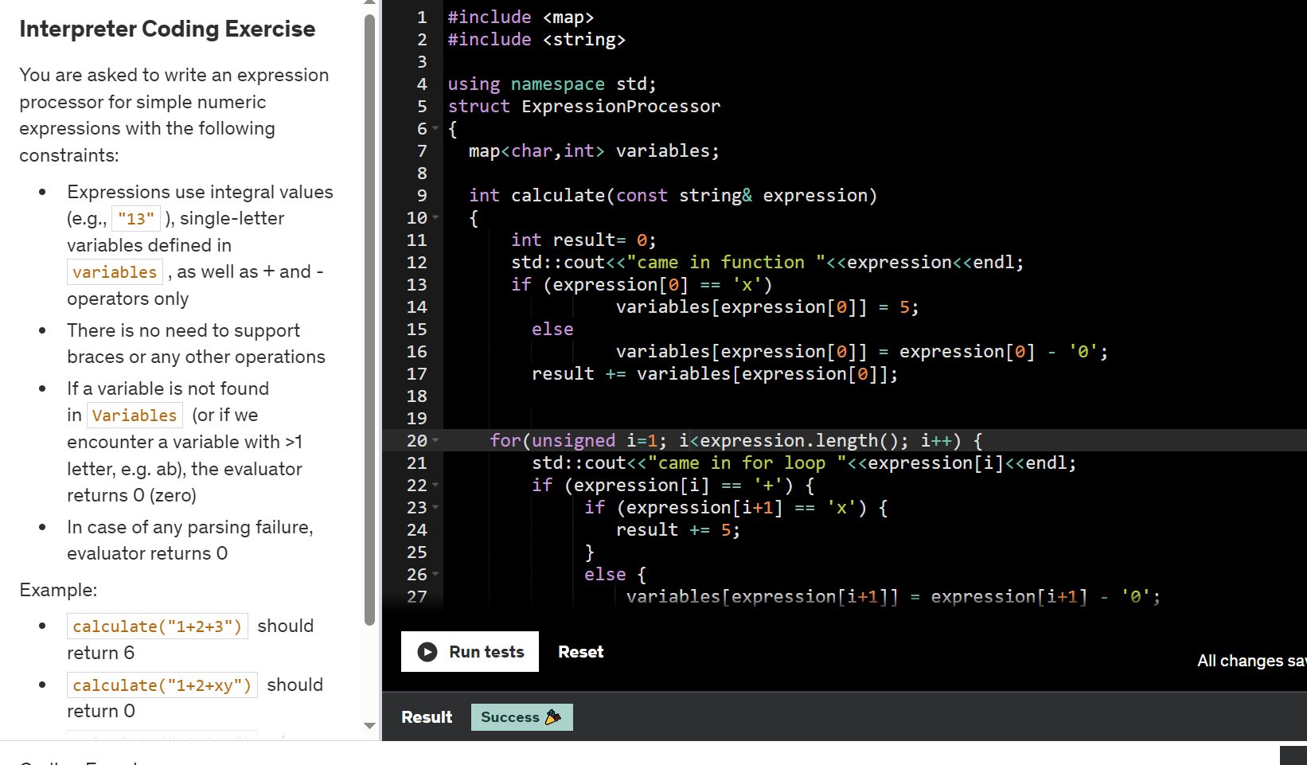

STATE DESIGN PATTERN :  
  
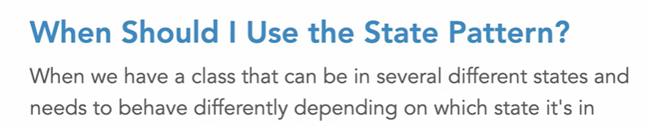

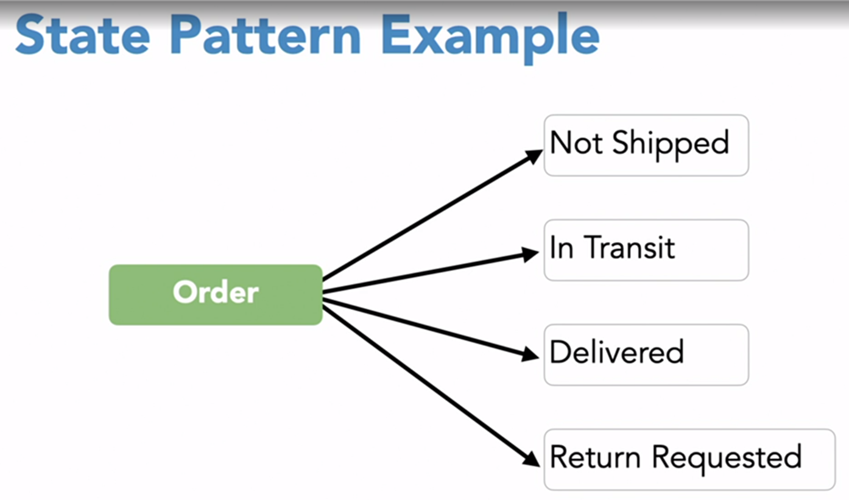

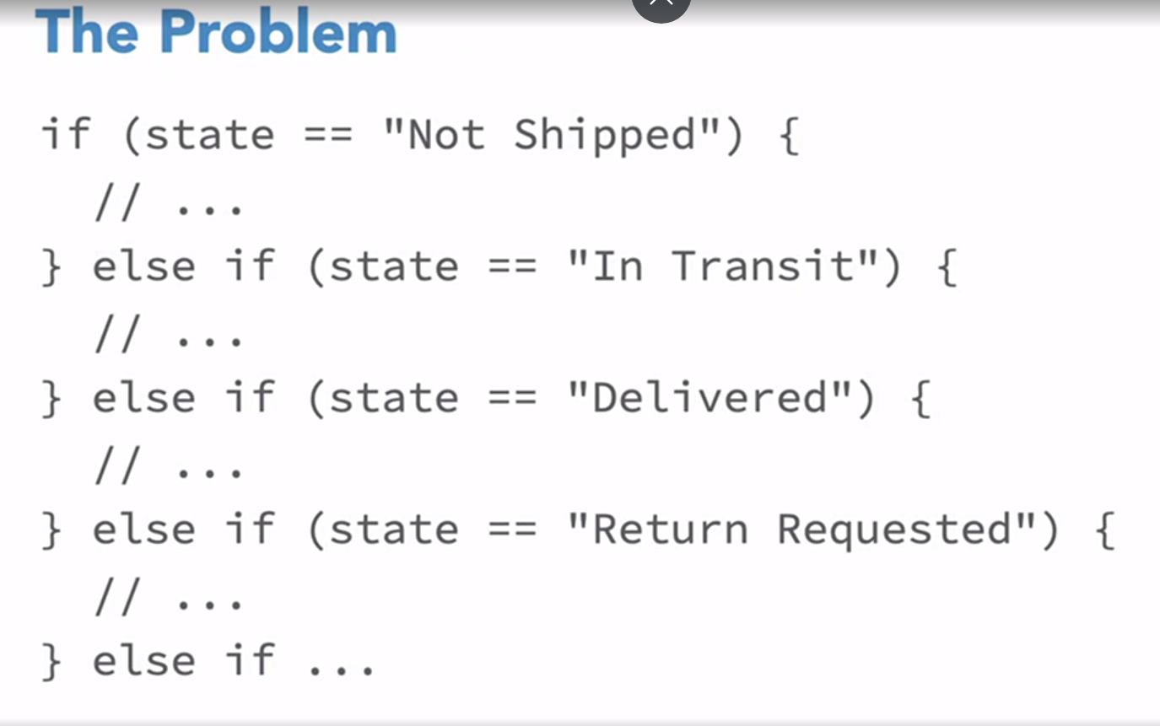  
  
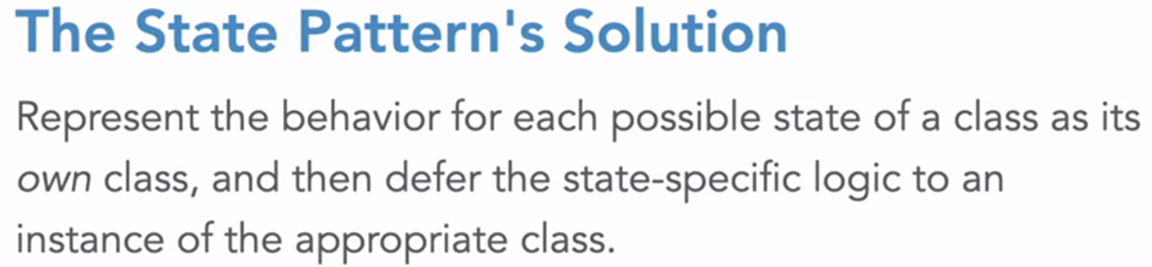  
  
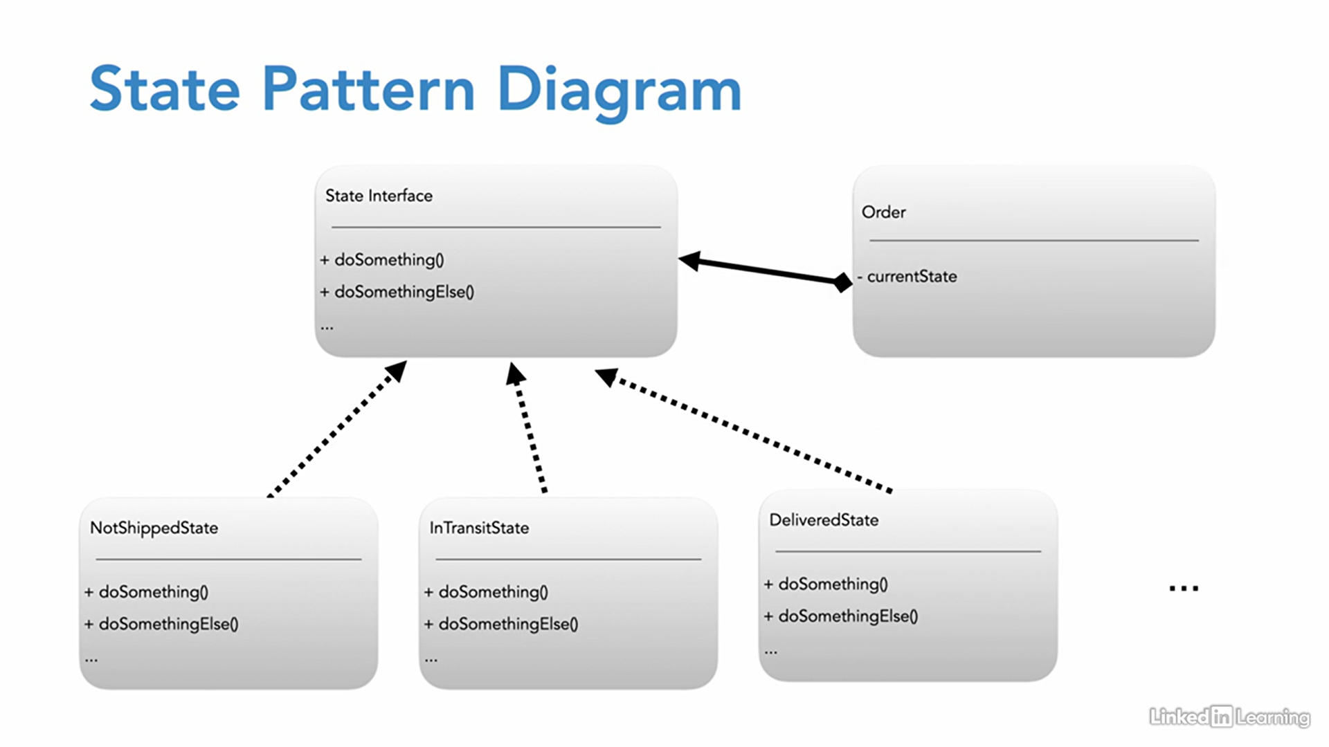

In Unified Modeling Language (UML), a filled diamond symbol at the end of an association line represents "composition" or "aggregation" between two classes.

Problematic code :

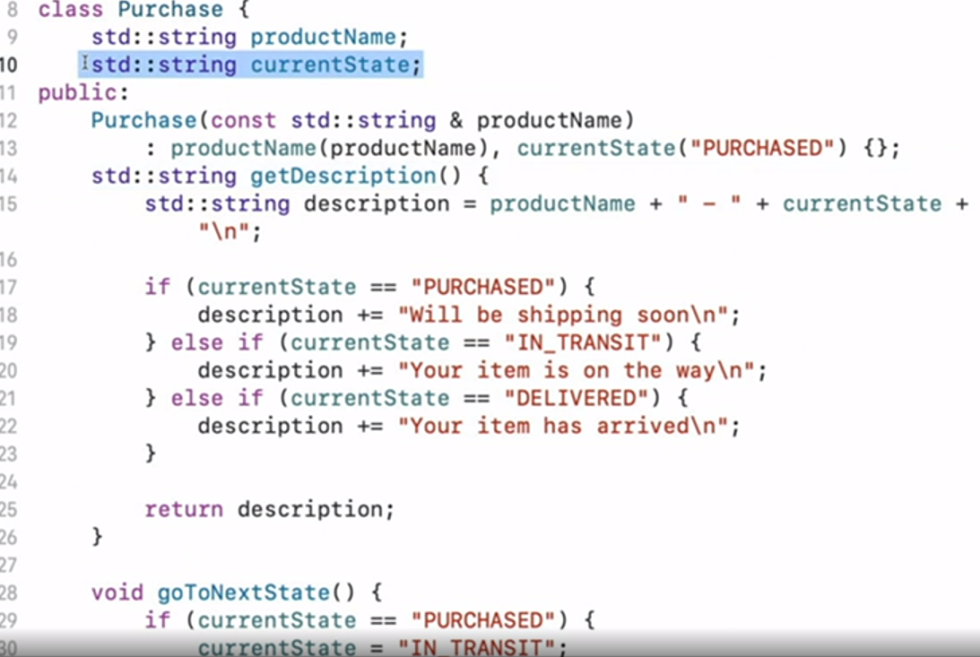

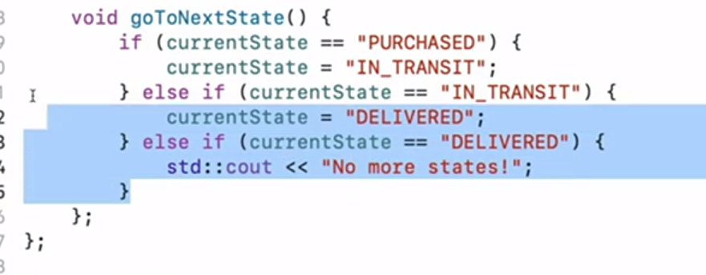

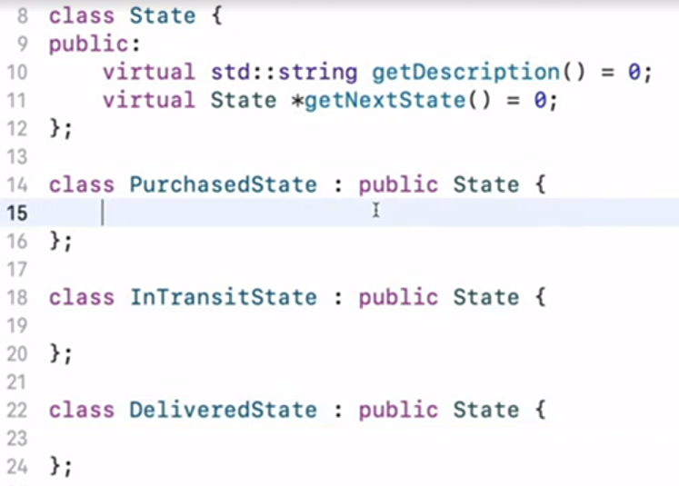

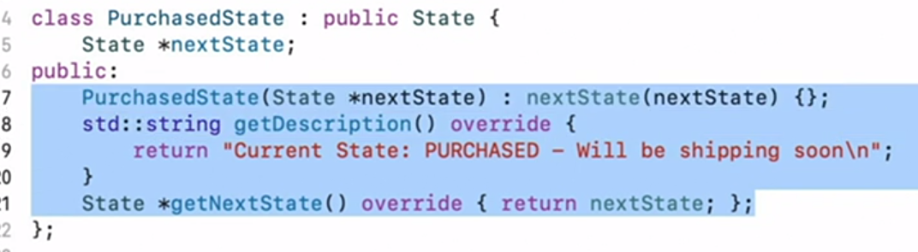

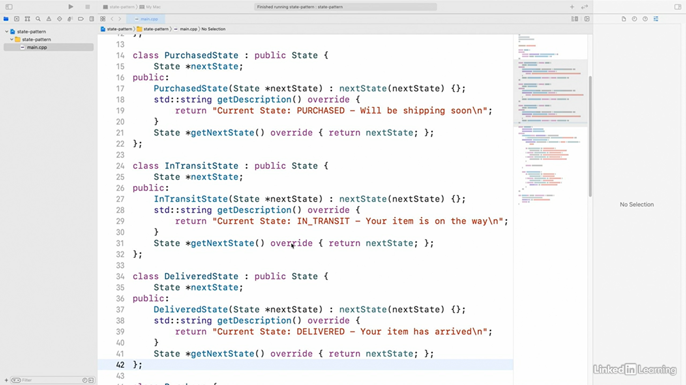

Purchase class contains State class (Composition or aggregation)

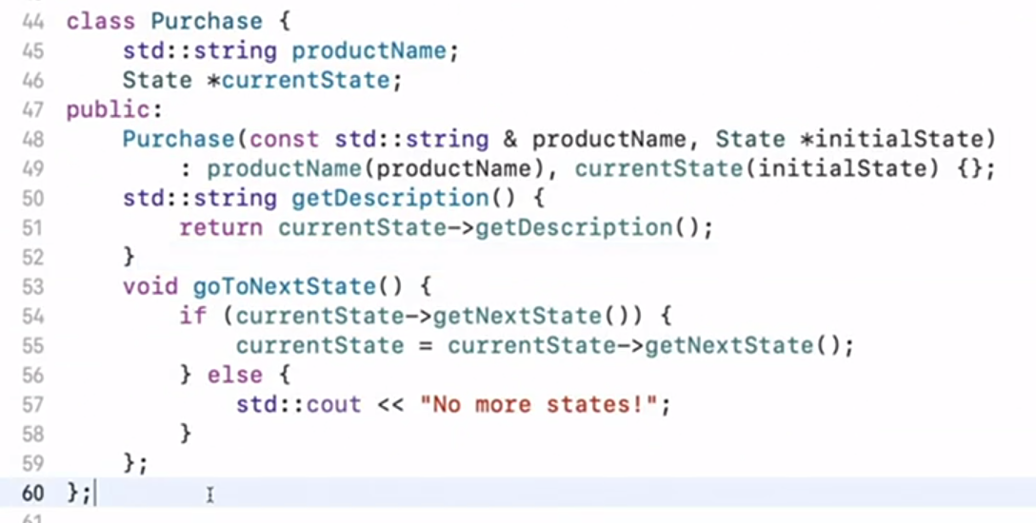

Client code :

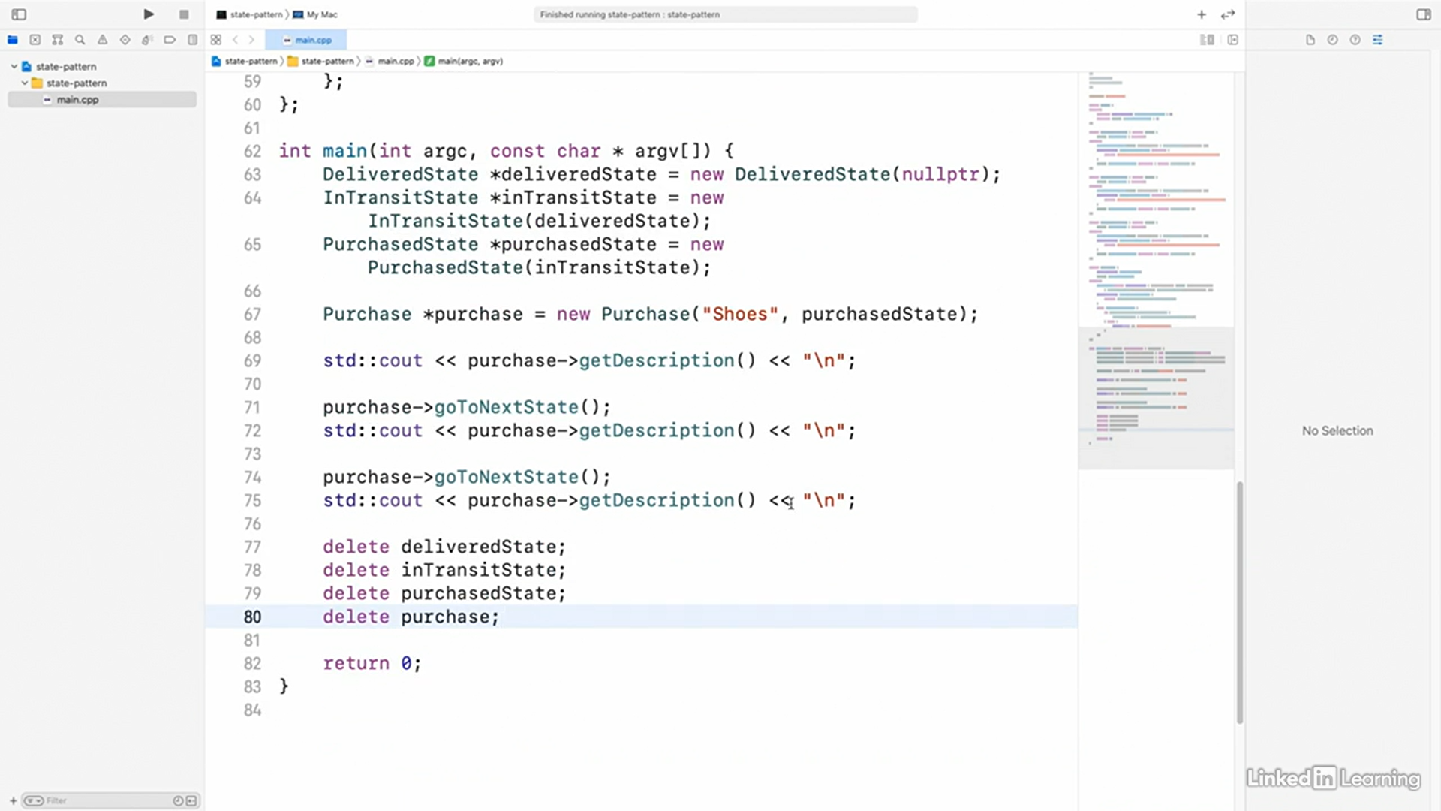

Output :   
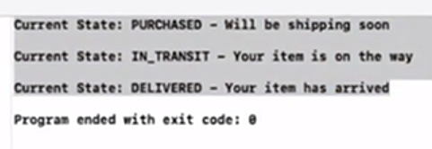

Case for implementing STATE design pattern :

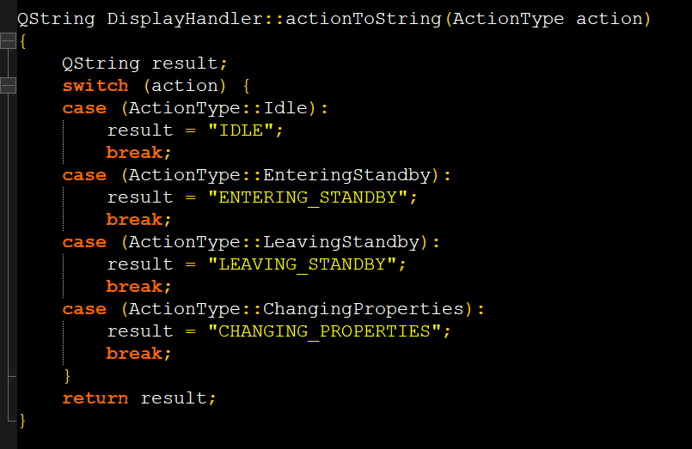

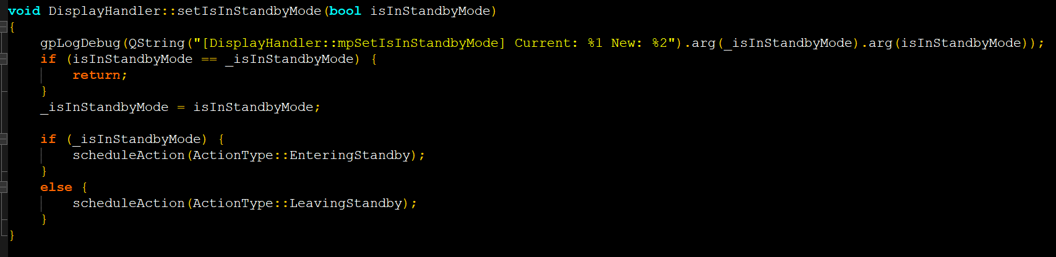

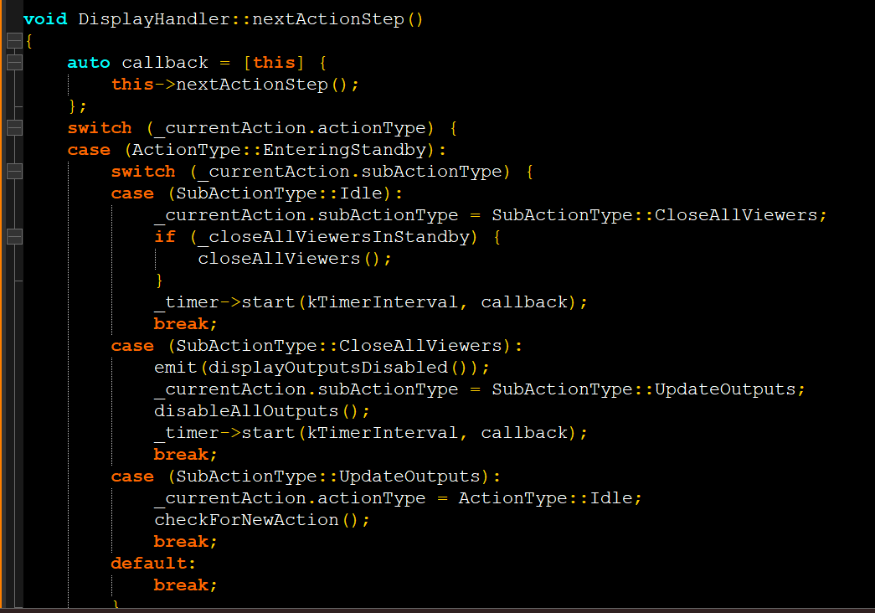

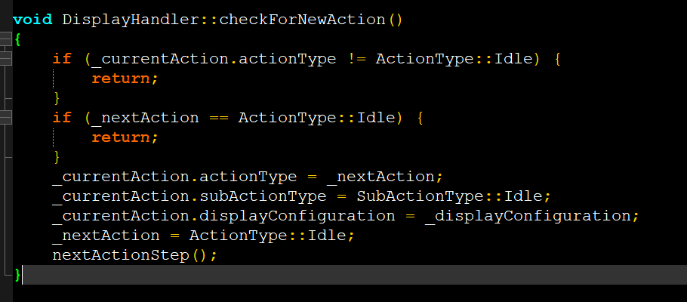

STATE DESIGN PATTERN : udemy

Fun with finite state machines.

STATE : A pattern in which the object’s behavior is determined by its state . An object transitions from one state to another ( something needs to trigger a transition.)  
A formalized construct which manages state and transitions is called a state machine.  
  
He has taken the example of phone ringing and picking, or phone silent and us picking for dialling.  
In code he has created a state class which has onState and offState in it.

And the implementation consists of overriding the opposite state function than the class that we are in.

He has a state interface class from which 2 concrete states offSTate and onSTate are derived, and LightSwitch is the class that uses these 2 states to switch on/ off the light.

In the example of phone call, he first created an enum for the phone state, then he created an enum for triggers for the set of states created above. Then he created RULES, which define to where can we go from the current state. For the rules he has a map<State, vector<pair<Trigger, State>>> rules;

One entry of this rule looks like this :

Rules[State::off_hook] = {  
 {Trigger::call_dialled, State::connecting},

{Trigger::stop_using_phone, State::on_hook}

};

* Next he gives an example of boost Meta state machine (MSM), and meta programming library (MPL) : didn’t understand this one at all.